[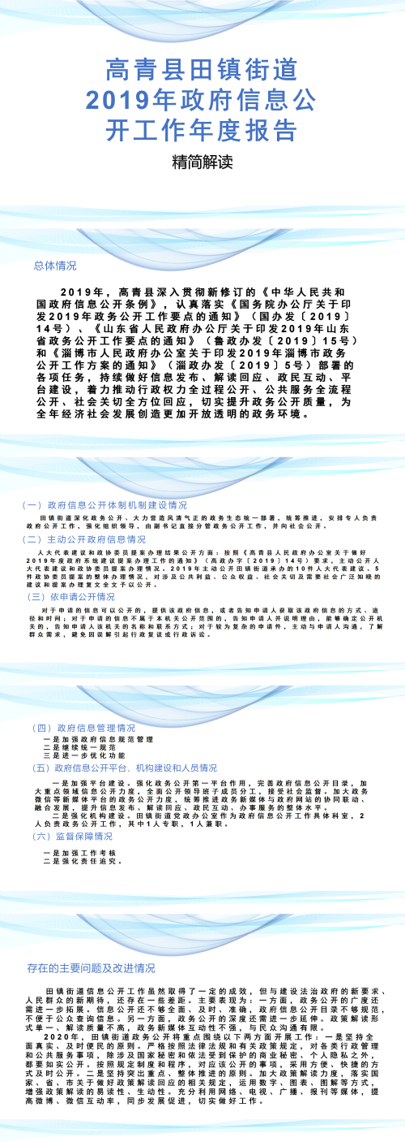](http://www.zibo.gov.cn/jcms/jcms_files/jcms1/web58/site/picture/0/0e4257dd624146ebb60ee5e3400ffa39.png)